**AEMC PROJECT ACTIVITY REPORT**

**TEAM1 - Group 5311**

**Bogza Gabriel** - Realization of the PCB

Used KiCad to create the layout for the PCB

Searching for footprints

Design the layout

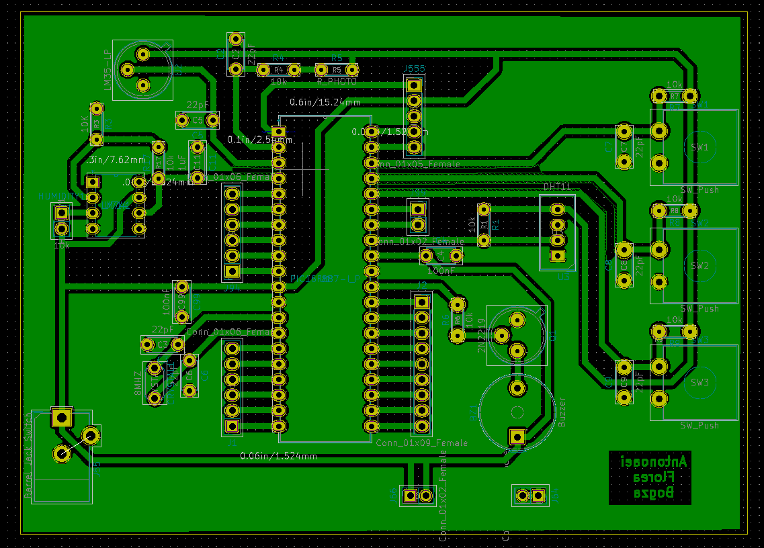

**3D simulation:**

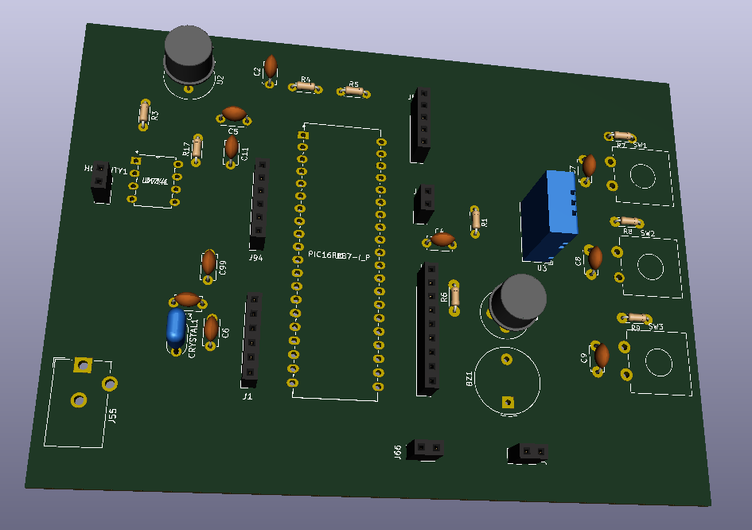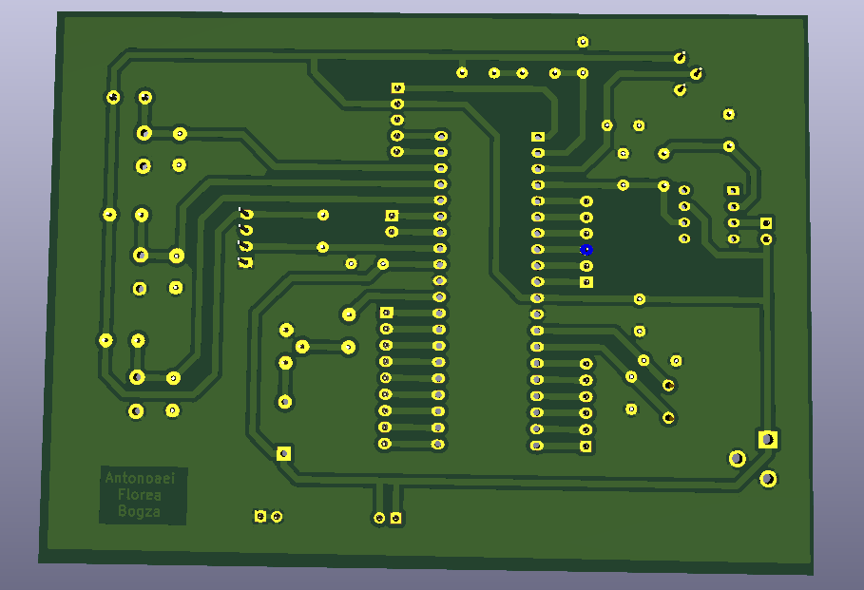

Order the components.

Multiple attempts to print the layout because the printer does not respect the sizes of pins.

Transfer the layout on the copper plate using the acetone and magazine paper method.

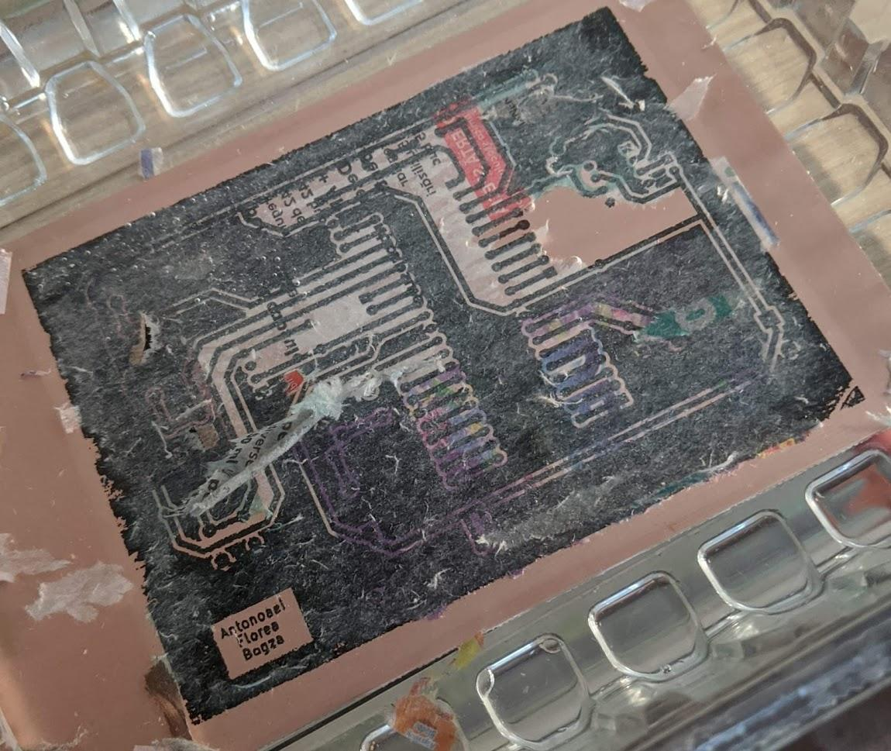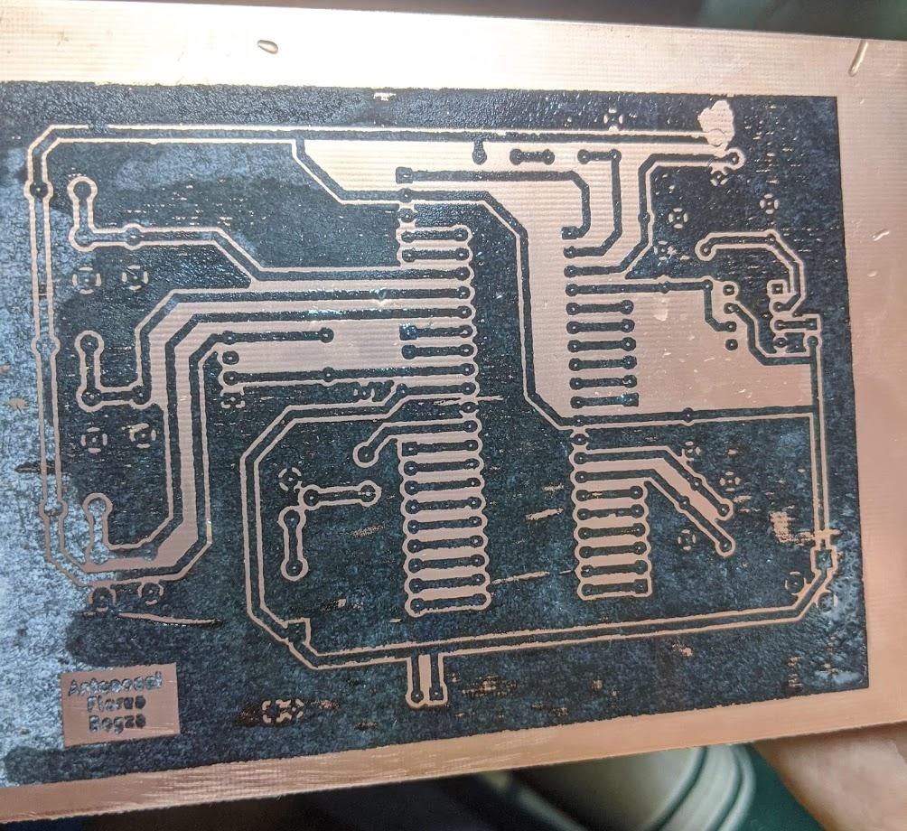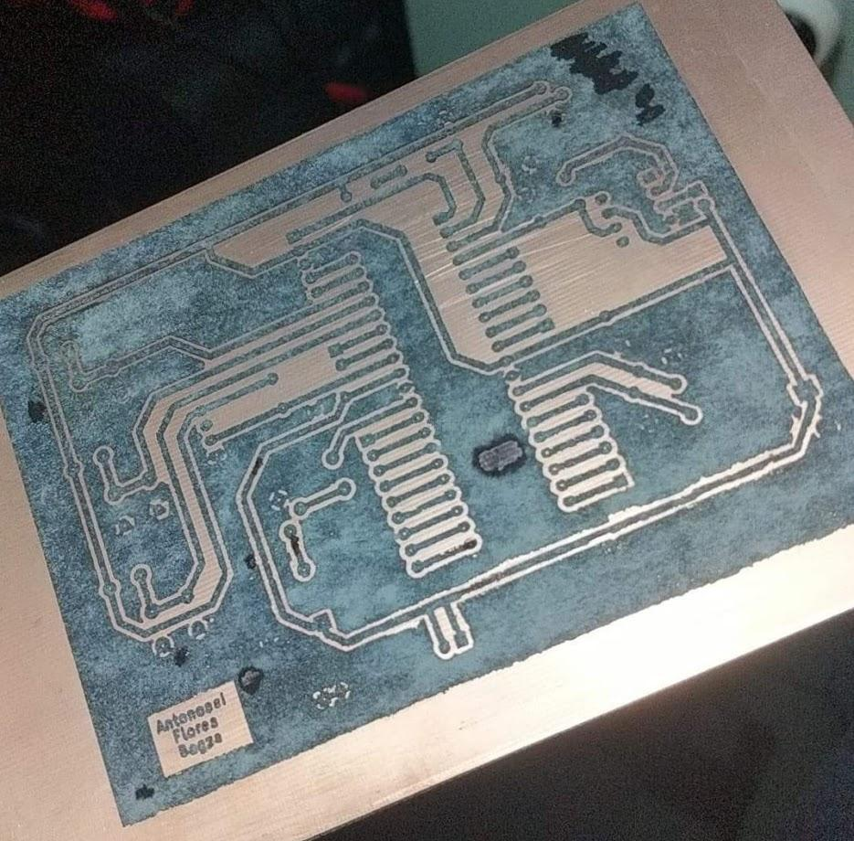

I corroded the PCB using ferric chloride.

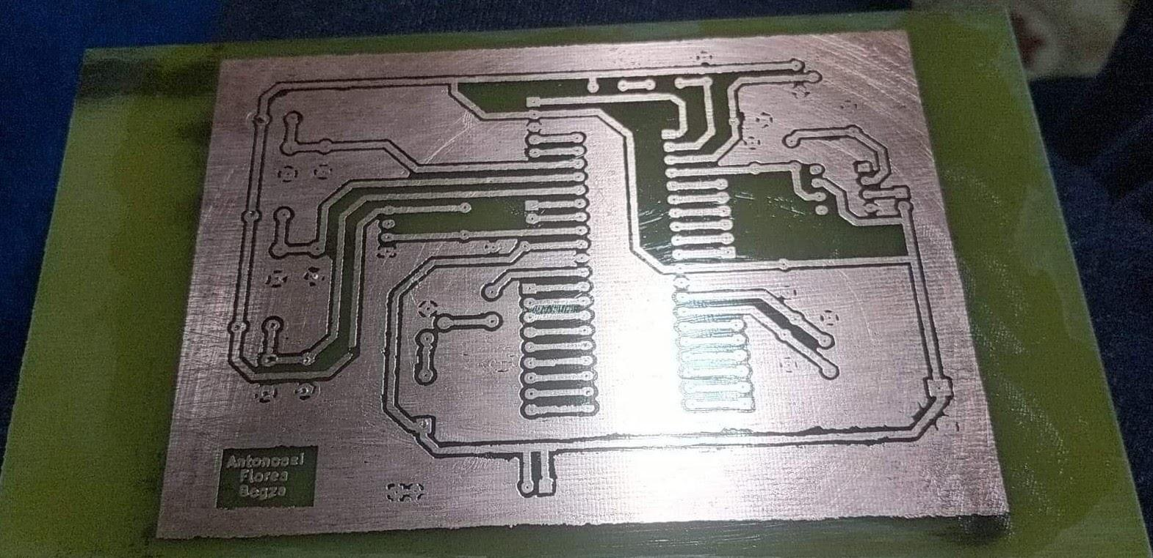

I drilled holes in the PCB to be able to add the components.

Soldered the components on the PCB

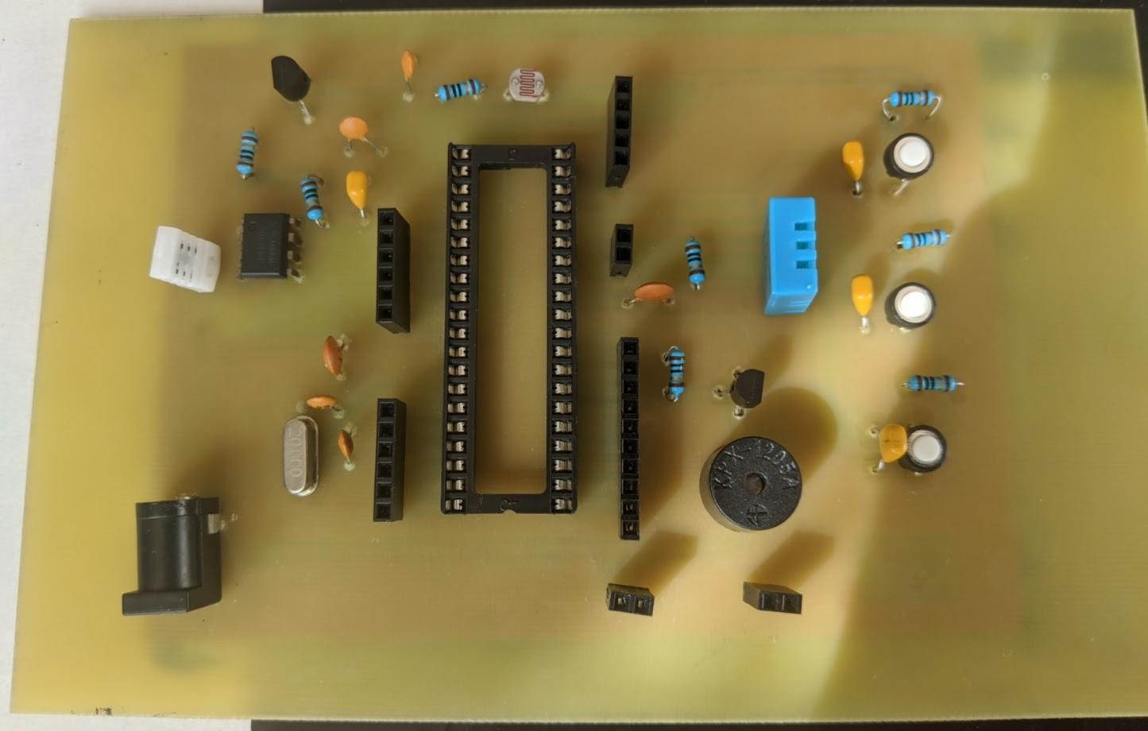

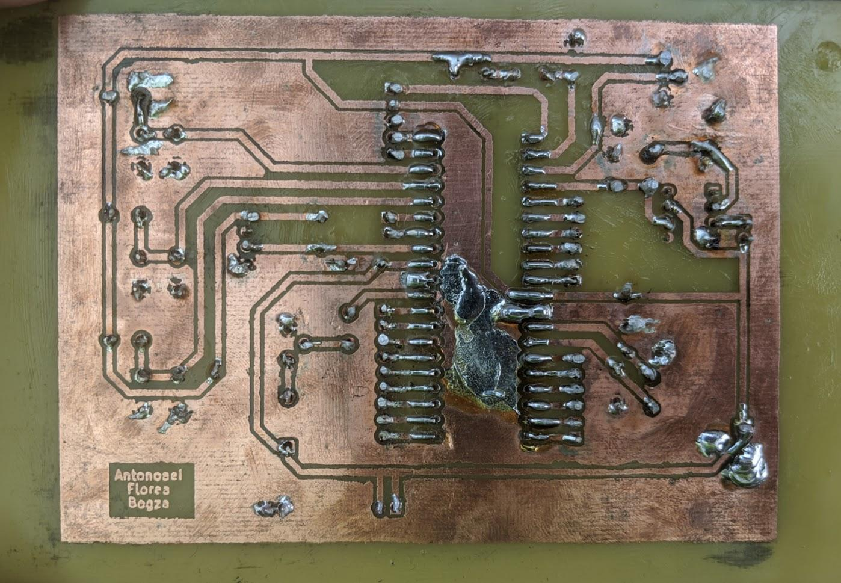

**Antonoaei Claudia-Schematic and code for Real Time clock**

I used Proteus 8.0 for my part. Dht11 can’t be found in Proteus 8.0 so we added it in 8.1.

This is the final schematic we used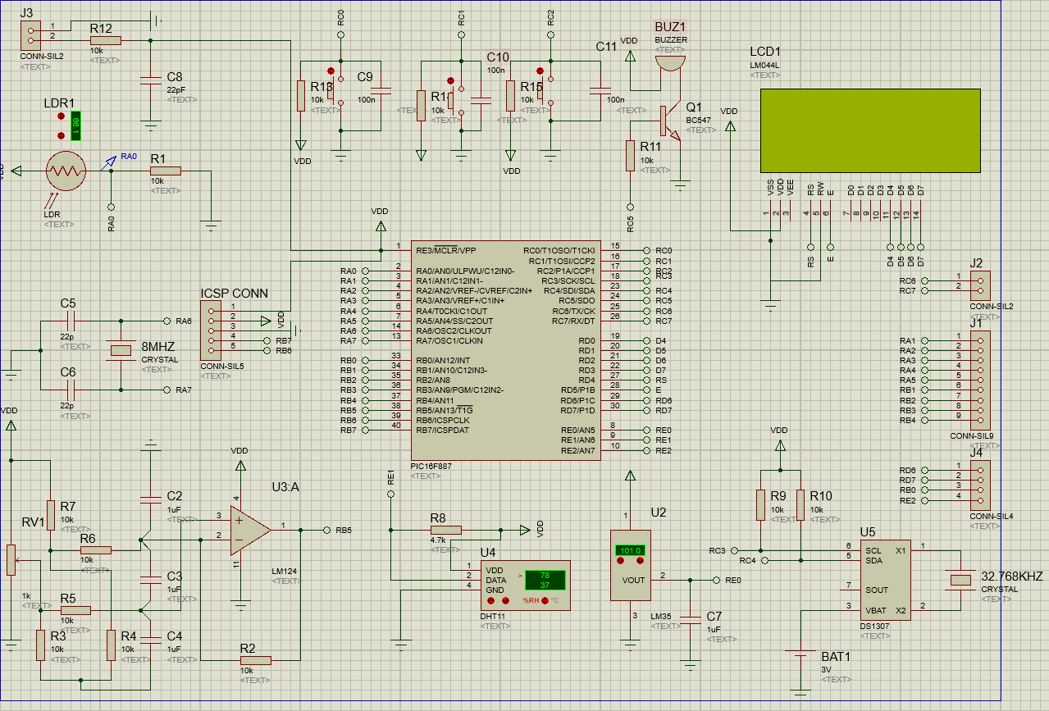

It should be noted that for the final code for the analog humidity sensor we used this schematic for testing, instead of the version of the amplifier in the last image.

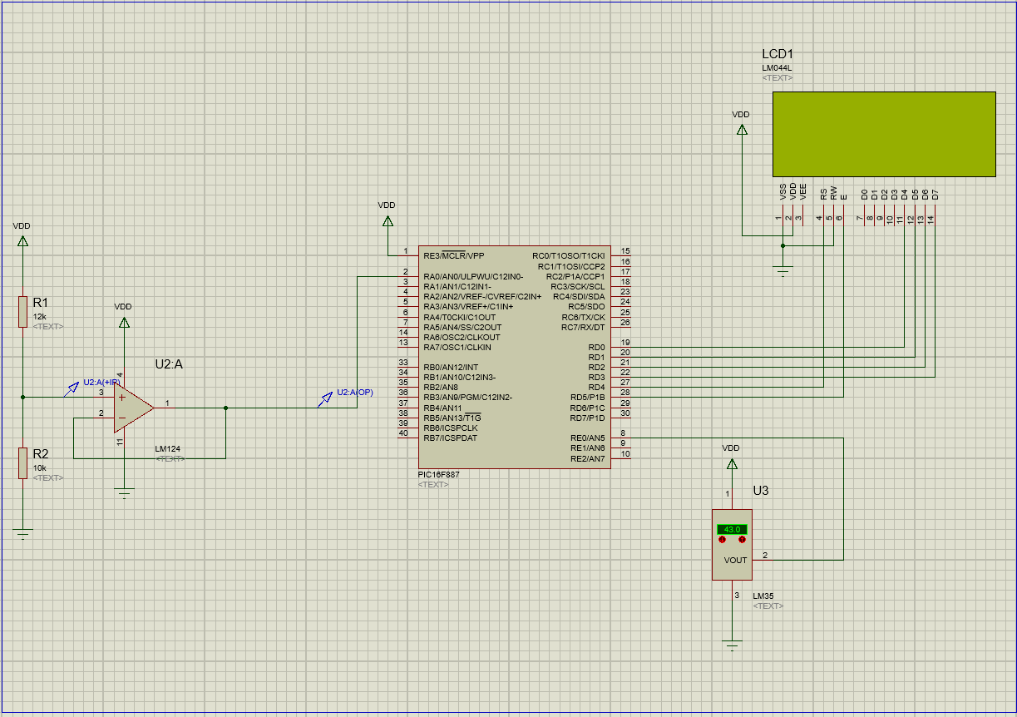

For the schematic, all colleagues made updates as necessary along the way.

For the code part I used Proteus 8.0. I did the code for the real time clock.

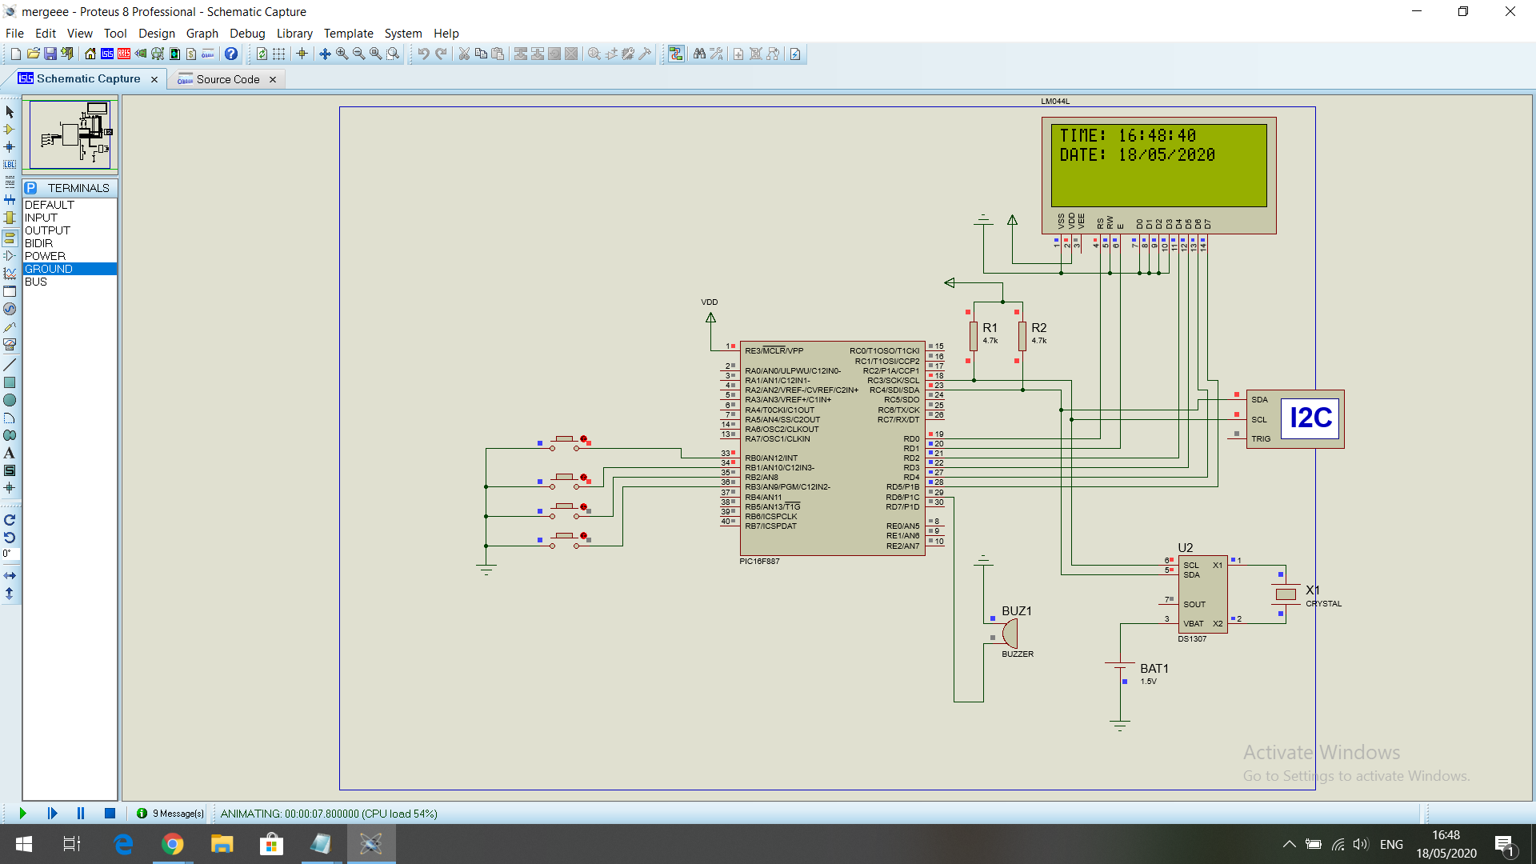

As you can see from the image, the real time clock is functional. Below I will list the code that I attached as well in the sent folder. This was not the first attempt at this, in fact it took several tries to make it work.

The used component for this particular simulation was DS1307 REAL TIME CLOCK.

#pragma config CONFIG1 = 0x2CD4

#pragma config CONFIG2 = 0x0700

#define button1 RB0

#define button2 RB1

#define buttonA1 RB2

#define buttonA2 RB3

#define LCD_RS RD0

#define LCD_EN RD1

#define LCD_D4 RD2

#define LCD_D5 RD3

#define LCD_D6 RD4

#define LCD_D7 RD5

#define LCD_RS_DIR TRISD0

#define LCD_EN_DIR TRISD1

#define LCD_D4_DIR TRISD2

#define LCD_D5_DIR TRISD3

#define LCD_D6_DIR TRISD4

#define LCD_D7_DIR TRISD5

#include <xc.h>

#define _XTAL_FREQ 8000000

#include <stdint.h>

#include <xc.h>

#include <stdio.h>

#include <string.h>

uint8_t i, second, minute, hour, m_day, month, year;

void LCD_Write_Nibble(uint8_t n);

void LCD_Cmd(uint8_t Command);

void LCD_Goto(uint8_t col, uint8_t row);

void LCD_PutC(char LCD_Char);

void LCD_Print(char* LCD_Str);

void LCD_Begin();

/********************** I2C functions **************************/

void I2C_Init(uint32_t i2c_clk_freq)

{

SSPCON = 0x28;

SSPADD = (_XTAL_FREQ/(4 * i2c_clk_freq)) - 1;

SSPSTAT = 0;

}

void I2C_Start()

{

while ((SSPSTAT & 0x04) || (SSPCON2 & 0x1F));

SEN = 1;

}

void I2C_Repeated_Start()

{

while ((SSPSTAT & 0x04) || (SSPCON2 & 0x1F));

RSEN = 1;

}

void I2C_Stop()

{

while ((SSPSTAT & 0x04) || (SSPCON2 & 0x1F));

PEN = 1;

}

void I2C_Write(uint8_t i2c_data)

{

while ((SSPSTAT & 0x04) || (SSPCON2 & 0x1F));

SSPBUF = i2c_data;

}

uint8_t I2C_Read(uint8_t ack)

{

uint8_t _data;

while ((SSPSTAT & 0x04) || (SSPCON2 & 0x1F));

RCEN = 1;

while ((SSPSTAT & 0x04) || (SSPCON2 & 0x1F));

_data = SSPBUF;

while ((SSPSTAT & 0x04) || (SSPCON2 & 0x1F));

ACKDT = !ack;

ACKEN = 1;

return _data;

}

/********************** end I2C functions **********************/

// a small function for button1 (B1) debounce

__bit debounce ()

{

uint8_t count = 0;

for(uint8_t i = 0; i < 5; i++) {

if (button1 == 0)

count++;

__delay_ms(10);

}

if(count > 2) return 1;

else return 0;

}

/********************** RTC chip functions *********************/

uint8_t bcd_to_decimal(uint8_t number) {

return((number >> 4) * 10 + (number & 0x0F));

}

uint8_t decimal_to_bcd(uint8_t number) {

return(((number / 10) << 4) + (number % 10));

}

void RTC_display()

{

static char Time[] = "TIME: 00:00:00";

static char Date[] = "DATE: 00/00/2000";

second = bcd_to_decimal(second);

minute = bcd_to_decimal(minute);

hour = bcd_to_decimal(hour);

m_day = bcd_to_decimal(m_day);

month = bcd_to_decimal(month);

year = bcd_to_decimal(year);

Time[6] = hour / 10 + '0';

Time[7] = hour % 10 + '0';

Time[9] = minute / 10 + '0';

Time[10] = minute % 10 + '0';

Time[12] = second / 10 + '0';

Time[13] = second % 10 + '0';

Date[6] = m_day / 10 + '0';

Date[7] = m_day % 10 + '0';

Date[9] = month / 10 + '0';

Date[10] = month % 10 + '0';

Date[14] = year / 10 + '0';

Date[15] = year % 10 + '0';

LCD_Goto(1, 1);

LCD_Print(Time);

LCD_Goto(1, 2);

LCD_Print(Date);

}

void blink()

{

uint8_t j = 0;

while(j < 100 && button1 && button2) {

j++;

__delay_ms(5);

}

}

uint8_t edit(uint8_t x, uint8_t y, uint8_t parameter)

{

while(debounce());

while(1) {

while(!button2)

{

parameter++;

if(i == 0 && parameter > 23)

parameter = 0;

if(i == 1 && parameter > 59)

parameter = 0;

if(i == 2 && parameter > 31)

parameter = 1;

if(i == 3 && parameter > 12)

parameter = 1;

if(i == 4 && parameter > 99)

parameter = 0;

LCD_Goto(x, y);

LCD_PutC(parameter / 10 + '0');

LCD_PutC(parameter % 10 + '0');

__delay_ms(200);

}

LCD_Goto(x, y);

blink();

LCD_Goto(x, y);

LCD_PutC(parameter / 10 + '0');

LCD_PutC(parameter % 10 + '0');

blink();

if(!button1)

if(debounce())

{

i++;

return parameter;

}

}

return 0;

}

/********************** end RTC chip functions *****************/

/*************************** main function *********************/

void main(void)

{

OSCCON = 0X70;

ANSELH = 0;

nRBPU = 0;

WPUB = 0x03;

__delay_ms(1000);

I2C_Init(100000);

LCD_Begin();

while(1) {

if(!button1)

if(debounce())

{

i = 0;

hour = edit(7, 1, hour);

minute = edit(10, 1, minute);

m_day = edit(7, 2, m_day);

month = edit(10, 2, month);

year = edit(15, 2, year);

while(debounce());

minute = decimal_to_bcd(minute);

hour = decimal_to_bcd(hour);

m_day = decimal_to_bcd(m_day);

month = decimal_to_bcd(month);

year = decimal_to_bcd(year);

I2C_Start();

I2C_Write(0xD0);

I2C_Write(0);

I2C_Write(0);

I2C_Write(minute);

I2C_Write(hour);

I2C_Write(1);

I2C_Write(m_day);

I2C_Write(month);

I2C_Write(year);

I2C_Stop();

__delay_ms(200);

}

I2C_Start();

I2C_Write(0xD0);

I2C_Write(0);

I2C_Repeated_Start();

I2C_Write(0xD1);

second = I2C_Read(1);

minute = I2C_Read(1);

hour = I2C_Read(1);

I2C_Read(1);

m_day = I2C_Read(1);

month = I2C_Read(1);

year = I2C_Read(0);

I2C_Stop();

RTC_display();

__delay_ms(50);

}

}

Below, I will list the modified functions for the alarm as well

void alarms_read_display() // read and display alarm1 and alarm2 data function

{

I2C_Start();

I2C_Write(0xD0);

I2C_Write(0x08);

I2C_Repeated_Start();

I2C_Write(0xD1);

alarm1_minute = I2C_Read(1);

alarm1_hour = I2C_Read(1);

I2C_Read(1);

I2C_Read(1);

I2C_Read(1);

control_reg = I2C_Read(1);

status_reg = I2C_Read(1);

I2C_Read(1);

I2C_Read(1);

I2C_Read(1);

I2C_Stop();

alarm1_minute = bcd_to_decimal(alarm1_minute);

alarm1_hour = bcd_to_decimal(alarm1_hour);

Alarm1[8] = alarm1_minute % 10 + '0';

Alarm1[7] = alarm1_minute / 10 + '0';

Alarm1[5] = alarm1_hour % 10 + '0';

Alarm1[4] = alarm1_hour / 10 + '0';

}

__bit debounce (uint8_t button)

{

uint8_t count = 0;

for(uint8_t i = 0; i < 5; i++)

{

switch (button)

{

case 1: if (button1 == 0)

count++;

break;

case 3: if (buttonA1 == 0)

count++;

break;

default: break;

}

__delay_ms(10);

}

if(count > 2) return 1;

else return 0;

}

void alarm_check(){

if((alarm1_minute == ((minute & 0x0F) + (minute >> 4) * 10)) &&

(alarm1_hour == ((hour & 0x0F) + (hour >> 4) * 10)) && (second == 0))

Buzzer=1;

}

**Alexandru Florea-code**

Code for humidity sensor:

/*Template Proiect AEMC - ETTI Iasi*/

#include <xc.h>

__PROG_CONFIG(1,0x20D4); // config. uC

__PROG_CONFIG(2,0x0000); // config. uC

#define LED1 RB0

#define LED2 RB1

#define _XTAL_FREQ 8000000

char *stringumid = (char *) "umiditate analogica";

void init_uC(void);

void interrupt etti(void); // functie de intreruperi globala ptr. TOATE intreruperile de pe un

void init_LCD(void);

void lcd_goto(unsigned char pos);

void lcd_puts(char * s);

void lcd_putch(char c);

void senzumid(void);

unsigned int Citeste_ADC(unsigned char canal);

int temperatura[] = {0,5,10,15,20,25,30,35,40,45,50};

const double matricetabel[11][15] = {

{0, 0, 12000, 5200, 2800, 720, 384, 200, 108, 64, 38, 23, 16 ,10.2,6.9},

{0, 19800, 9800, 4700, 2000, 510, 271, 149, 82, 48, 29, 18, 12, 8.2, 5.4},

{0, 16000, 7200, 3200, 1400, 386, 211, 118, 64, 38, 24, 15, 10.2, 6.9, 4.7},

{21000, 10500, 5100, 2350, 1050, 287, 159, 91, 51, 31, 19, 12, 8.1, 5.5, 4.1},

{13500, 6700, 3300, 1800, 840, 216, 123, 70, 40, 25, 16, 10, 7.2, 4.7, 3.2},

{9800, 4803, 2500, 1300, 630, 166, 95, 55, 31, 20, 13, 8.5, 5.7, 4.0, 2.8},

{8000, 3900, 2000, 980, 470, 131, 77, 44, 25, 17, 10.5, 7.2, 5.0, 3.6, 2.5},

{6300, 3100, 1500, 750, 385, 104, 63, 38, 21, 13, 9, 6.4, 4.4, 3.2, 2.3},

{4600, 2300, 1100, 575, 282, 80, 52, 32, 17, 11, 8.2, 5.8, 4.0, 2.9, 2.1},

{3800, 1850, 900, 430, 210, 66, 45, 30, 14, 9, 7.1, 5.0, 3.3, 2.4, 1.8},

{3200, 1550, 750, 350, 170, 51, 38, 24, 12, 8, 6.0, 4.1, 2.9, 2.0, 1.5},

};

int umid[]={20,25,30,35,40,45,50,55,60,65,70,75,80,85,90};

void main(void)

{

init_uC();

init_LCD();

while (1)

{

senzumid();

}

}

void init_uC (void)

{

OSCCON = 0x71; // setez Osc. intern uC de 8MHz // pag. 64

ANSELH = 0x00;

ADCON0 = 0b10000001;

ADCON1 = 0x80;

T1CON=0x10;

TMR1H=0;

TMR1L=0;

TRISA = 0x01;

TRISB = 0x00;

TRISC = 0x01;

TRISD = 0x00;

TRISE = 0b00000011;

ANSEL = 0b00000001;

PORTB = 0b00000000; // initializez PORTB cu valori de 0 logic

OPTION_REG = 0b00000111;// Frecv. intrare T0 = Frecv. Osc./4 (=8MHz/4) = 2MHz

// prescaler=256 => Frecv. T0 = 2MHz/256 = KHz (sau T=128us)

TMR0IF = 0; //

TMR0 = 178; // porneste numararea de la valoarea 178; pana la maxim (255)

TMR0IE = 1; // activez intreruperea ptr. T0

GIE = 1; // activez Global intreruperile

}

void interrupt etti(void) // ajung aici la fiecare 78*128us=~10ms

{

if(TMR0IF) // daca flagul TMR0IF=1

{

TMR0IF = 0; // obligatoriu - sterg flagul Timerului care a generat intreruperea

TMR0 = 178; //

LED2 = !LED2; //

}

}

unsigned int Citeste_ADC(unsigned char canal)

{

if(canal > 13)

return 0;

ADCON0 &= 0xC3;

ADCON0 |= (canal << 2);

__delay_ms(100);

GO_nDONE = 1;

while(GO_nDONE);

return ((ADRESH<<8)+ADRESL);

}

void senzumid(void)

{

int temptabel = 1, umidtabel = 0;

float templm;

templm = Citeste_ADC(5);

templm = templm*4.882;

templm=templm/10.0;

int i;

for(i=0;i<=10;i++)

{ if(templm>=temperatura[i])

{

temptabel++;

}

}

float imp;

imp = Citeste_ADC(0);

imp=imp*4.882;

imp=imp/1000.0;

imp = (10.0*(5-imp)/imp);

if(temptabel==0)

{

umidtabel=2;

}

if(temptabel == 1)

{

umidtabel=1;

}

if(temptabel == 2)

{

umidtabel=1;

}

while(imp<=matricetabel[temptabel][umidtabel])

{

umidtabel++;

}

int val=(int)umid[umidtabel];

__delay_ms(2);

lcd_goto(0x80);

__delay_ms(2);

lcd_puts(stringumid);

lcd_goto(0xC0);

lcd_putch((val/10)%10+'0');

__delay_ms(2);

lcd_putch((val)%10+'0');

__delay_ms(2);

lcd_putch('%');

}

Code for LM35,photoresistor+DHT11

/*Template Proiect AEMC - ETTI Iasi*/

#include <xc.h>

#include<math.h>

__PROG_CONFIG(1,0x20D4); // config. uC

__PROG_CONFIG(2,0x0000); // config. uC

#define _XTAL_FREQ 8000000

#define LED2 RB1

#define butoninc RC2

#define butonalarm RC1

#define butontimp RC0

#define dhtpin RE1

#define dhtpin_dir TRISE1

char *tempanalog = (char *) " Temperatura LM35";

char *luminanalog = (char *) "luminozitate";

char *tempdht = (char *) "temp dht";

char *umiddht = (char *) "umid dht";

char *pag1 = (char *) "pagina 1";

char *pag2 = (char *) "pagina 2";

char *pag3 = (char *) "pagina 3";

char *lum = (char *) "lumeni/m^2";

void init_uC(void);

void interrupt etti(void); // functie de intreruperi globala ptr. TOATE intreruperile de pe un

void init_LCD(void);

void lcd_goto(unsigned char pos);

void lcd_puts(char * s);

void lcd_putch(char c);

void lcd_clear(void);

void lm35(void);

void luminozitate(void);

void initializare_dht(void);

unsigned short raspuns_dht(void);

unsigned short citire_dht(unsigned short *);

void afisare_dht(void);

void afisarepag(void);

unsigned int Citeste_ADC(unsigned char canal);

char temperatura[]="temperatura = 00.0C";

char umiditate[]="umiditate = 00.0%";

unsigned short tempbyte1, tempbyte2, umidbyte1, umidbyte2, suma;

void main(void)

{

init_uC();

init_LCD();

while(1)

{

afisarepag();

}

}

void init_uC (void)

{

OSCCON = 0x71; // setez Osc. intern uC de 8MHz // pag. 64

ADCON0 = 0b10000001;

ADCON1 = 0x80;

T1CON=0x10;

TMR1H=0;

TMR1L=0;

TRISA = 0x01;

TRISB = 0x00;

TRISC = 0x00;

TRISD = 0x00;

TRISE = 0b00000011;

ANSEL = 0b00000001;

ANSELH = 0x00;

PORTB = 0b00000000; // initializez PORTB cu valori de 0 logic

OPTION_REG = 0b00000111;// Frecv. intrare T0 = Frecv. Osc./4 (=8MHz/4) = 2MHz

// prescaler=256 => Frecv. T0 = 2MHz/256 = KHz (sau T=128us)

TMR0IF = 0; //

TMR0 = 178; // porneste numararea de la valoarea 178; pana la maxim (255)

TMR0IE = 1; // activez intreruperea ptr. T0

GIE = 1; // activez Global intreruperile

}

unsigned int Citeste_ADC(unsigned char canal)

{

if(canal > 13)

return 0;

ADCON0 &= 0xC3;

ADCON0 |= (canal << 2);

__delay_ms(100);

GO_nDONE = 1;

while(GO_nDONE);

return ((ADRESH<<8)+ADRESL);

}

void lm35(void)

{

int adc,temp1,c1,c2,c3,c4;

float volt,temp;

adc=Citeste_ADC(5);

volt=adc*4.882;

temp=volt;

temp1=temp;

c1=(temp1/1000)%10;

c2=(temp1/100)%10;

c3=(temp1/10)%10;

c4=(temp1/1)%10;

__delay_ms(2);

lcd_goto(0xC1);

__delay_ms(2);

lcd_puts(tempanalog);

__delay_ms(2);

lcd_goto(0x99);

__delay_ms(2);

lcd_putch(c1+'0');

__delay_ms(2);

lcd_putch(c2+'0');

__delay_ms(2);

lcd_putch(c3+'0');

lcd_puts(".");

__delay_ms(2);;

lcd_putch(c4+'0');

__delay_ms(2);

lcd_putch(0xDF);

__delay_ms(2);

lcd_puts("C");

}

void luminozitate(void)

{

int adc,c1,c2,c3,c4;

float r1=10.0,curent;

float lv,lum,ressenz;

adc=Citeste_ADC(0);

lv=adc*4.882;

lv/=1000;

ressenz=(5-lv)/(lv/r1);

ressenz=(pow(10,5.07)*pow(ressenz,(-0.9)))/10;

int result=(int)ressenz;

c1=(result/1000)%10;

c2=(result/100)%10;

c3=(result/10)%10;

c4=(result/1)%10;

__delay_ms(2);

lcd_goto(0xC4);

__delay_ms(2);

lcd_puts(luminanalog);

__delay_ms(2);

lcd_goto(0x98);

__delay_ms(2);

lcd_putch(c1+'0');

__delay_ms(2);

lcd_putch(c2+'0');

__delay_ms(2);

lcd_puts(".");

__delay_ms(2);

lcd_putch(c3+'0');

__delay_ms(2);

lcd_putch(c4+'0');

__delay_ms(2);

lcd_puts("lumeni/m^2");

}

void initializare_dht(void)

{

dhtpin_dir = 0;

dhtpin = 0;

__delay_ms(25);

dhtpin = 1;

__delay_us(25);

dhtpin_dir = 1;

}

unsigned short raspuns_dht()

{

TMR1H = 0;

TMR1L = 0;

TMR1ON = 1;

while(!dhtpin && TMR1L < 100);

if(TMR1L > 99)

return 0;

else { TMR1H = 0;

TMR1L = 0;

while(dhtpin && TMR1L < 100);

if(TMR1L > 99)

{

return 0;

}

else

{

return 1;

}

}

}

unsigned short citire_dht(unsigned short* dhtdata)

{

short i;

*dhtdata = 0;

for( int i = 0; i < 8; i++)

{

TMR1H=0;

TMR1L=0;

while(!dhtpin)

{

if(TMR1L > 100)

{

return 1;

}

TMR1H = 0;

TMR1L = 0;

}

while(dhtpin)

if(TMR1L > 100)

if(TMR1L > 100)

{

return 1;

}

if(TMR1L > 50)

*dhtdata |=(1<<(7-i));

}

return 0;

}

void afisare_dht(void)

{

initializare_dht();

if(raspuns_dht())

{

if(citire_dht(&umidbyte1) || citire_dht(&umidbyte2) || citire_dht(&tempbyte1) || citire_dht(&tempbyte2) || citire_dht(&suma))

{

lcd_clear();

lcd_goto(0x80);

lcd_puts((char *) "eroare la citirea datelor");

}

else {

if(suma == ((umidbyte1 + umidbyte2 + tempbyte1 + tempbyte2) & 0xFF))

{

temperatura[14] = (tempbyte1/10 + 48);

temperatura[15] = (tempbyte1%10 + 48);

temperatura[17] = (tempbyte2/10 + 48);

umiditate[12] = (umidbyte1/10 + 48);

umiditate[13] = (umidbyte1%10 + 48);

umiditate[15] = (umidbyte2/10 + 48);

temperatura[18] = 223;

lcd_goto(0xC2);

lcd_puts(temperatura);

lcd_goto(0x96);

lcd_puts(umiditate);

}

else {

lcd_clear();

lcd_goto(0x80);

lcd_puts((char*) "verifica suma");

}

}

}

else {

lcd_goto(0x80);

lcd_puts((char*) "Niciun");

lcd_goto(0xC0);

lcd_puts((char*) "raspuns");

}

TMR1ON = 0;

__delay_ms(1000);

}

void afisarepag(void)

{

unsigned k=0;

do{

lcd_goto(0x86);

lcd_puts(pag1);

lm35();

k++;

}while(k<=50);

__delay_ms(100);

lcd_clear();

k=0;

do{

__delay_ms(10);

lcd_goto(0x86);

lcd_puts(pag2);

luminozitate();

k++;

}while(k<=50);

lcd_clear();

__delay_ms(10);

k=0;

do{

__delay_ms(10);

lcd_goto(0x86);

lcd_puts(pag3);

afisare_dht();

k++;

}while(k<=50);

lcd_clear();

__delay_ms(10);

k=0;

}

void interrupt etti(void) // ajung aici la fiecare 78*128us=~10ms

{

if(TMR0IF) // daca flagul TMR0IF=1

{

TMR0IF = 0; // obligatoriu - sterg flagul Timerului care a generat intreruperea

TMR0 = 178; //

LED2 = !LED2; //

}

}

The following table illustrates the calculus done for the luminosity sensor.

